CanadaHelps Connector for NPSP
Installation and Configuration

Note: You should only be installing this package if you are already using the CanadaHelps NPSP Connector package. If this is your first time installing the CanadaHelps Connector you should use the new Enterprise package.

CanadaHelps NPSP Connector Upgrade Instructions
Package installation
CanadaHelps NPSP Package
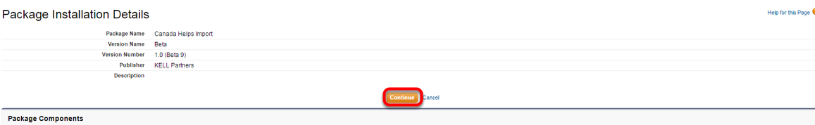
Click on the link for the CanadaHelps NPSP package and log into your Salesforce instance. Then click continue on the package installation details screen.
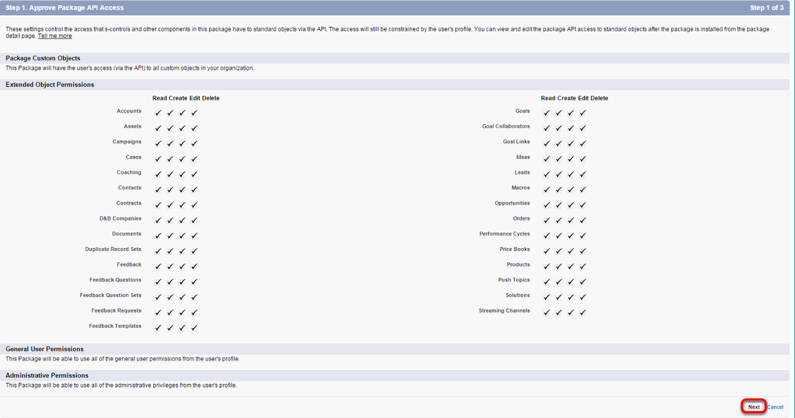

Click Next
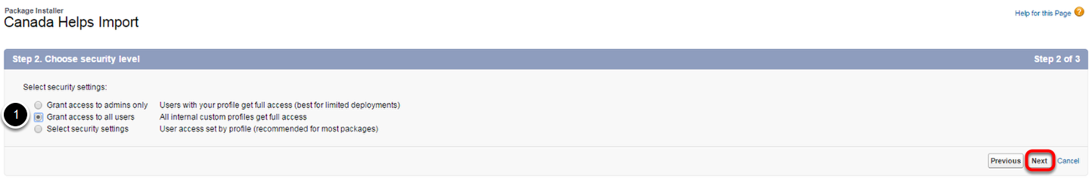
Select which user profile you want to have access to the package and click next.
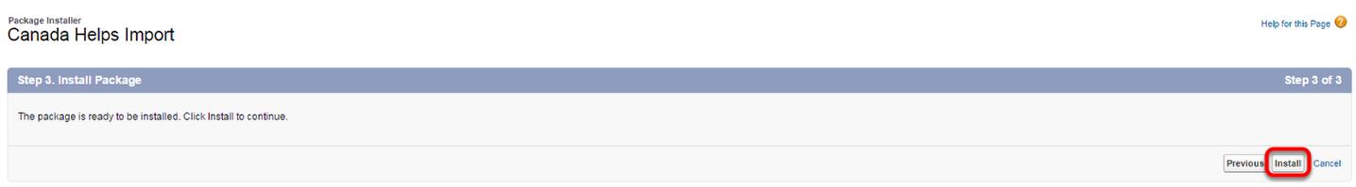
Click Install.

Updating Page Layouts
The CanadaHelps NPSP package will now be updated and you need to add the new custom fields to the appropriate account, contact and opportunity page layouts.
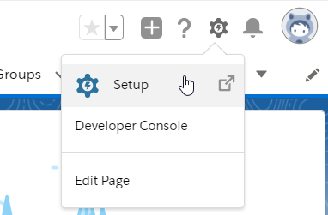
Proceed to the setting section of Salesforce
1) Click on the gear icon in the right hand corner
2) Click on Setup

Opportunity page layout
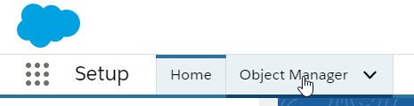
1) Click on Object Manager
2) Click on Opportunity in the resulting list (you can filter this list if necessary)
3) Click on Page Layouts

Select the page layout
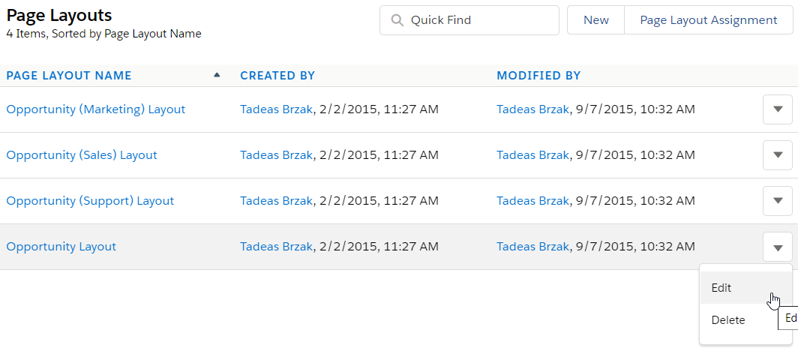
On the list of page layouts, click the dropdown arrow on the right and choose ‘Edit’, or simply click on the name of the page layout where you want to add the CanadaHelps custom fields.

Adding field to opportunity page layout
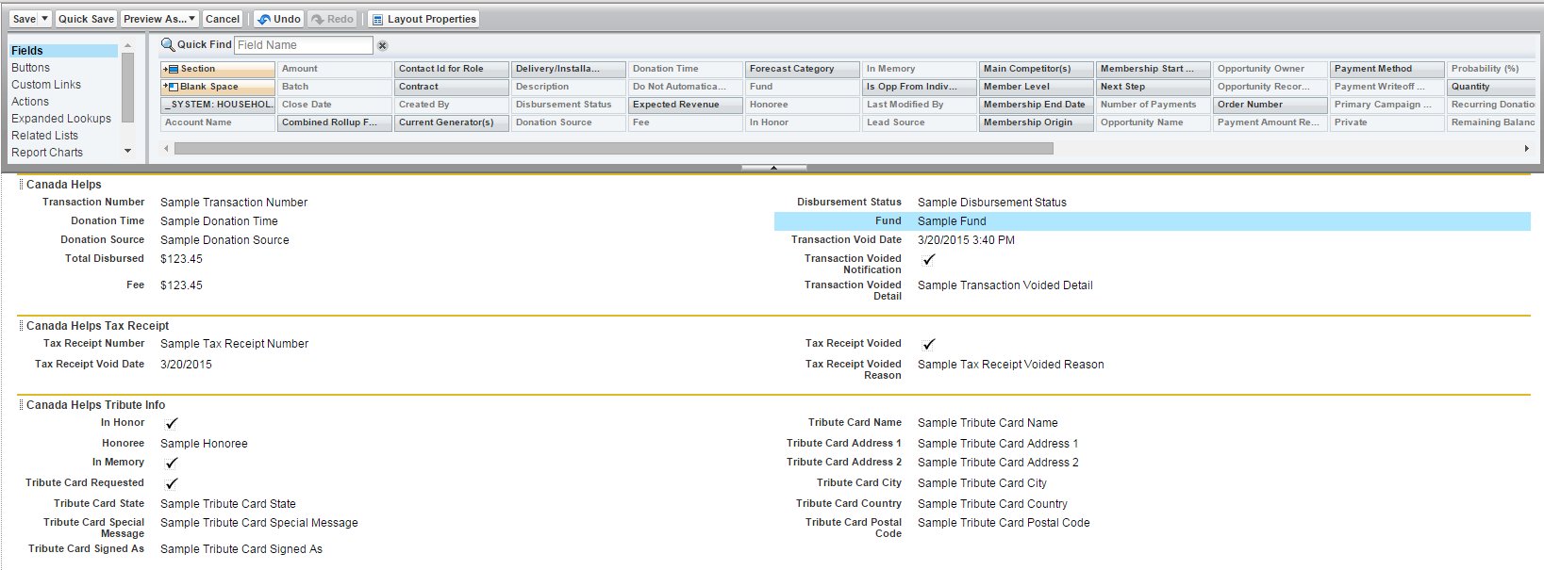
Here you can add the CanadaHelps custom opportunity fields to the page layout. The following custom fields are available:
Transaction Number
Payment Method
Receipt #
Fund Designation
Donation Date
Donation Time
Fee
Disbursement Status
Total Disbursed
In Honour Of
Honouree
In Memory Of
Card Requested
Card Name
Card Address 1
Card Address 2
Card City
Card Province/State
Card Country
Card Postal/Zip Code
Card Signed As
Card Special Message
Message To Charity
Voided Receipt
Receipt Voided Date
Receipt Voided Reason
Voided Trans Detail
Voided Trans Detail Date
Voided Trans Detail Reason
Trans Detail Voided Notification Email Sent
Donation Source

Account page layout
1) Click on Object Manager
2) Click on Account in the resulting list (you can filter this list if necessary)
3) Click on Page Layouts

Select the page layout
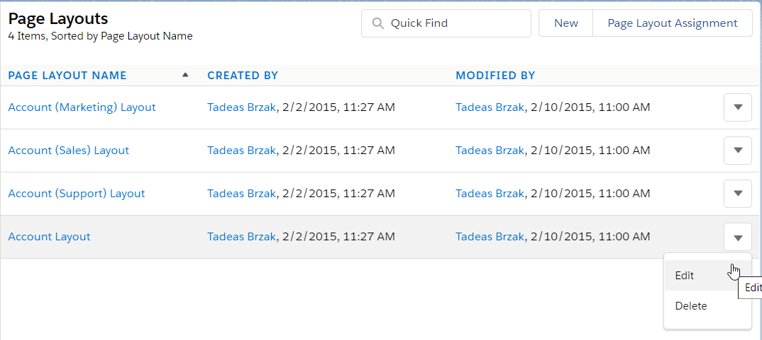
On the list of page layouts, click the dropdown arrow on the right and choose ‘Edit’, or simply click on the name of the page layout where you want to add the CanadaHelps custom fields.

Adding field to account page layout
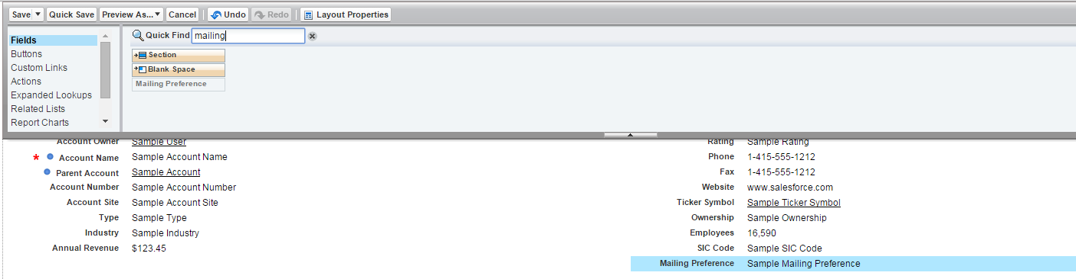
Here you can add the CanadaHelps custom account fields to the page layout. The following custom field is available:
Mailing Preference

CanadaHelps Imports Page Layout
1) Click on Object Manager
2) Click on CanadaHelps Import in the resulting list (you can filter this list if necessary)
3) Click on Page Layouts

Select the page layout
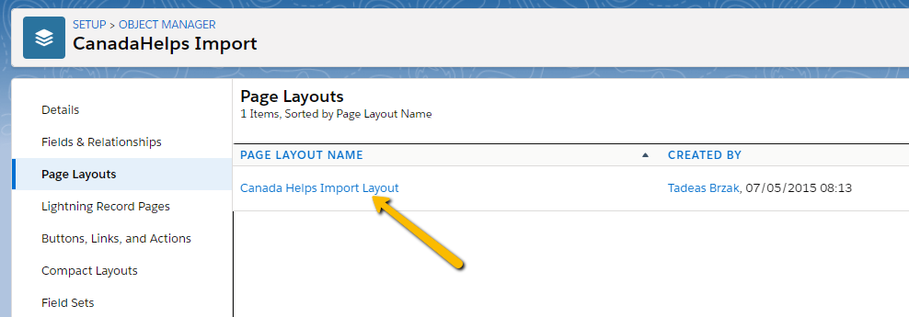
On the list of page layouts, click the dropdown arrow on the right and choose ‘Edit’, or simply click on the name of the page layout where you want to add the CanadaHelps custom fields.

Adding field to CanadaHelps Import page layout
Here you can add the new CanadaHelps custom account fields to the page layout. The following custom fields are available:
Import Number
Status

Changing the Related Lists

The new version does not use the Import Logs, but instead uses a new object called “CanadaHelps Imported Rows.” You will want to swap out these related lists:

While in the Page Layout edit view, click on Related Lists. Click and Drag the CanadaHelps Imported Rows list to the Related List section on the Page Layout. Then use the delete icon on the CanadaHelps Import Logs object to remove the Import Logs list from the layout. (Note: If you still want to reference the Logs for previous imports, go ahead and leave this list here)
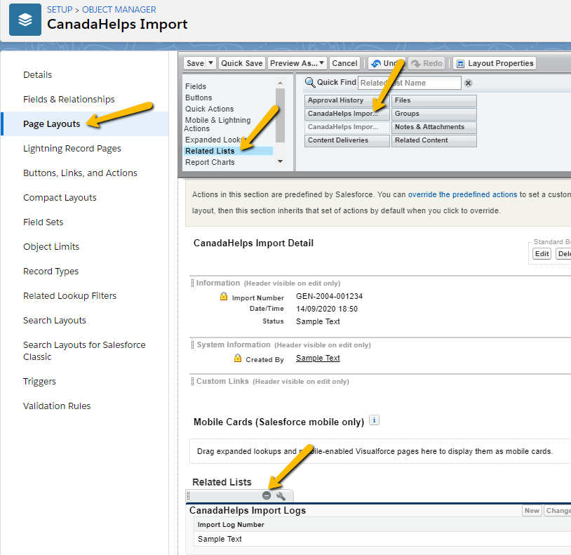

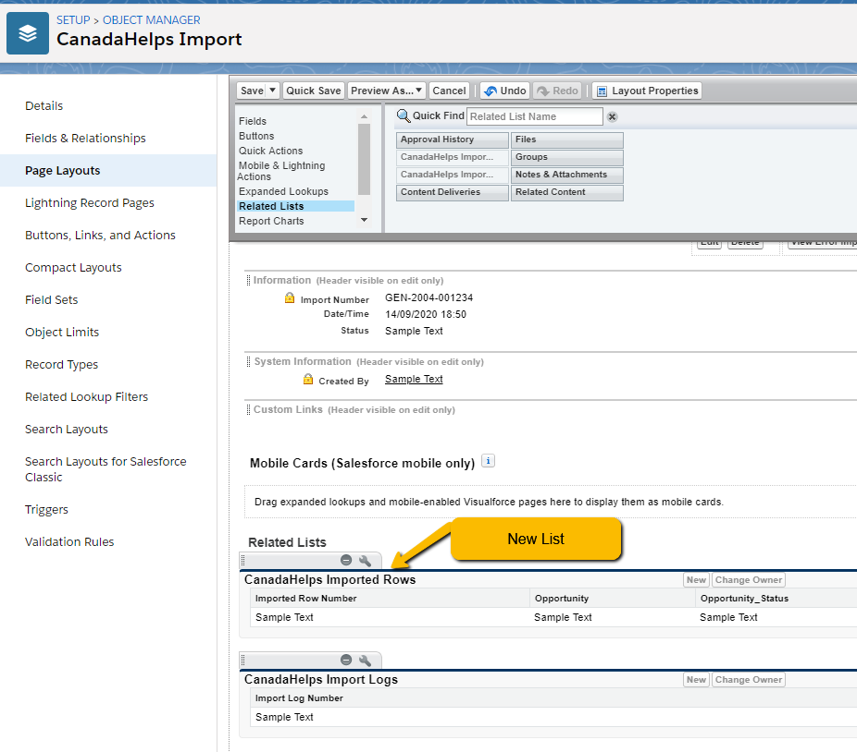
Save the page layout.

Adding Buttons to the Page Layout

The new Connector provides you with buttons to view the import logs as reports. You will have to add these buttons to your page layout. Navigate to the Page Layout edit view and click on “Buttons”. The click and drag the ‘View Error Import Log” and “View Import Log” buttons to the Custom Button section on the Page Layout. Click Save.

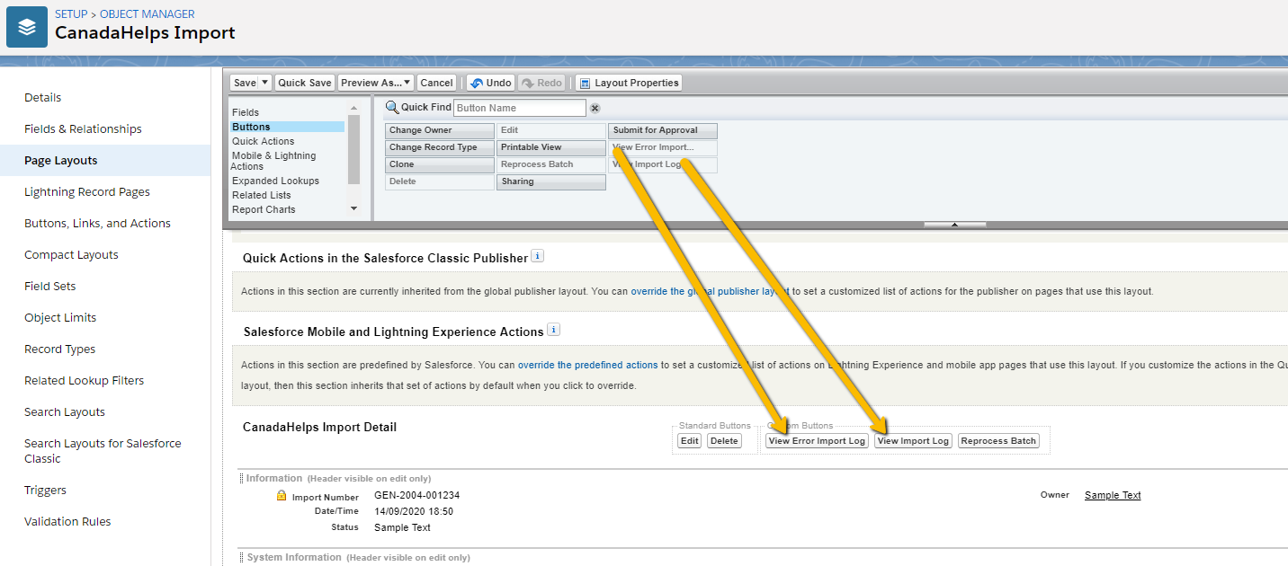
CanadaHelps Imported Row Page Layout
1) Click on Object Manager
2) Click on CanadaHelps Imported Row in the resulting list (you can filter this list if necessary)
3) Click on Page Layouts

Select the page layout
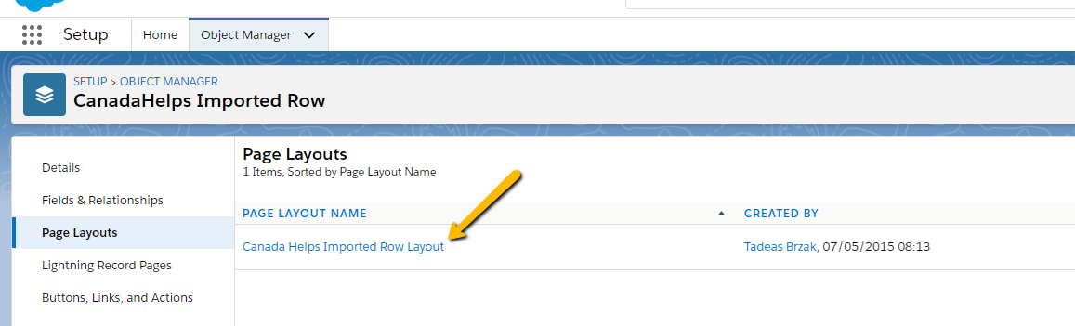
On the list of page layouts, click the dropdown arrow on the right and choose ‘Edit’, or simply click on the name of the page layout where you want to add the CanadaHelps custom fields.

Adding fields to CanadaHelps Imported Row page layout
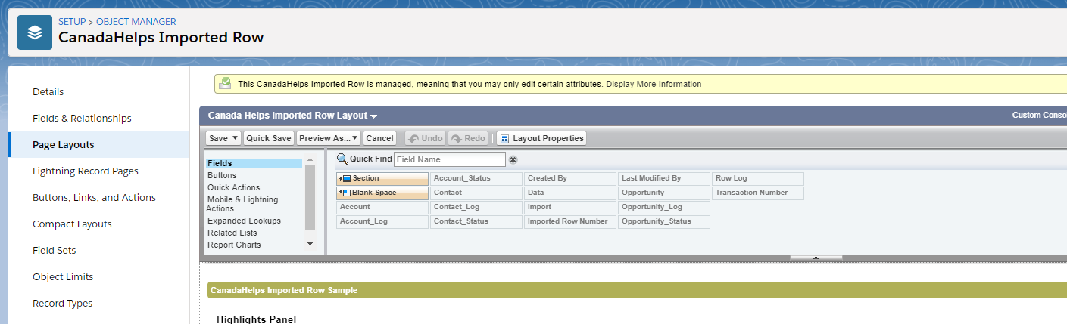
Here you can add the new CanadaHelps custom account fields to the page layout. The following custom fields are available:
Account – will link to an Account, if one was created through the Import process
Account_Log – Provides error messages from the package in case there was a problem importing Accounts. If you are having NPSP create Accounts automatically from new Contact records, this field will tell you the Account Creation was skipped.
Account_Status – Whether the Account information was imported successfully or not Contact – will link to a Contact, if one was created or updated through the Import process
Contact_Log - Provides error messages from the package in case there was a problem importing Contacts.
Contact_Status – Whether the Contact information was imported successfully or not
Import – Link to the Import Record
Opportunity – Link to the Created or Updated opportunity
Opportunity_Log - Provides error messages from the package in case there was a problem importing Contacts.
Opportunity_Status - Whether the Opportunity information was imported successfully or not

Changing the Related Lists

The new version does not use the Import Logs, but instead uses a new object called “CanadaHelps Imported Rows.” You will want to swap out these related lists:

While in the Page Layout edit view, click on Related Lists. Click and Drag the CanadaHelps Imported Rows list to the Related List section on the Page Layout. Then use the delete icon on the CanadaHelps Import Logs object to remove the Import Logs list from the layout. (Note: If you still want to reference the Logs for previous imports, go ahead and leave this list here)

Save the page layout.

Adding Buttons to the Page Layout

The new Connector provides you with buttons to view the import logs as reports. You will have to add these buttons to your page layout. Navigate to the Page Layout edit view and click on “Buttons”. The click and drag the ‘View Error Import Log” and “View Import Log” buttons to the Custom Button section on the Page Layout. Click Save.

CanadaHelps settings
The CanadaHelps settings object is where you configure the account model, the opportunity settings, contact deduplication settings and field mapping of this package.
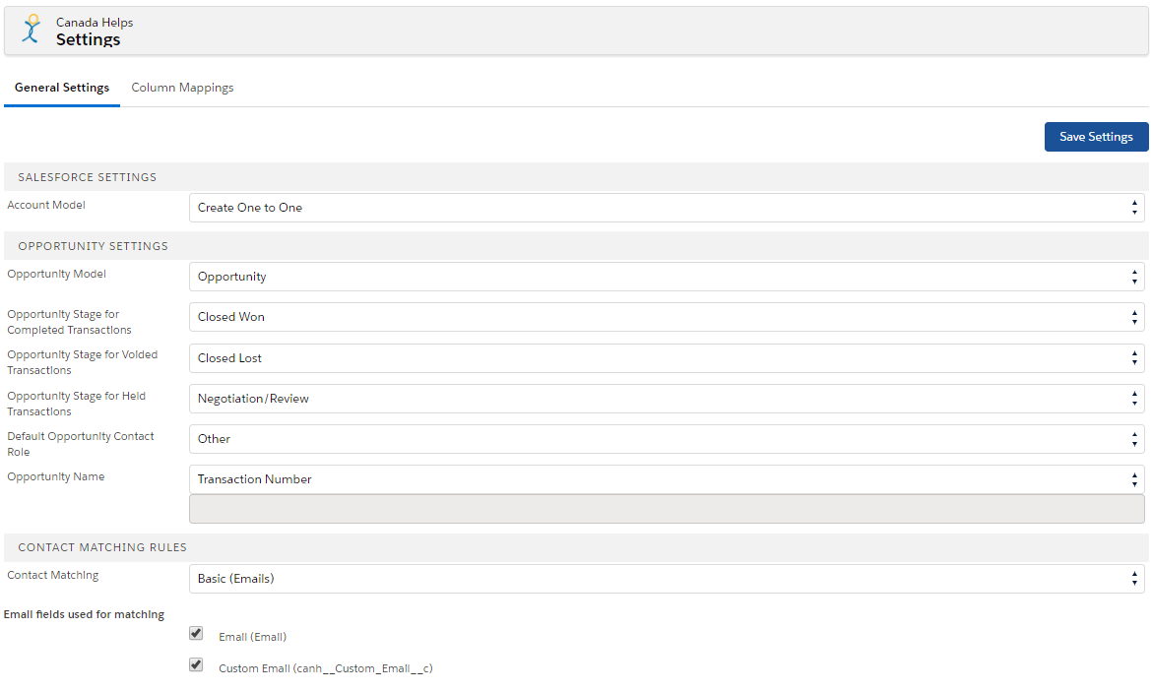

Salesforce settings
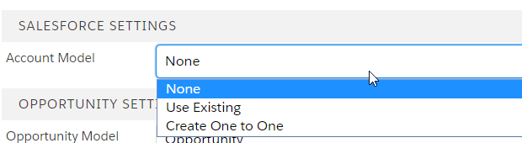
Since your organization uses NPSP (the Nonprofit Success Pack), select None here to allow NPSP to create Account records for new contacts. If you choose Use Existing, new contacts will be connected to a single Account record of your choosing. If you choose Create One to One, the Canada Helps Import package will create a new Account for each new Contact.

Opportunity Settings
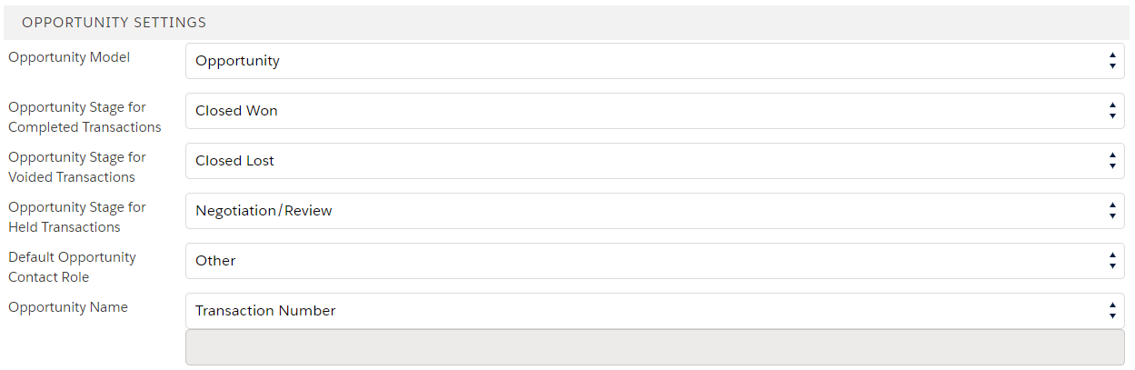
Opportunity Model – ‘Opportunity’ is the default setting. Since you are using NPSP, using the built-in NPSP Opportunity to Payment mapping functionality is recommended. However, you can select ‘Opportunity with Payments’ as the Opportunity Model to use the CanadaHelps import mappings to map transaction fields to the payment object if you wish.
Default Opportunity Contact Role - From the Opportunity Contact Role picklist select what role you want the donor to be assigned, this is applicable for individual donations only. If you are using NPSP, Opportunity Contact Role mappings will not be enabled by default and using NPSP functionality to create and manage contact roles on your opportunities is recommended, but if you wish you can manually adjust the mappings in the Column Mappings tab to have the import process create additional contact roles.
Opportunity Name - Here you can select from 3 options for Opportunity naming conventions:
Default – CanadaHelps will not set the opportunity name and naming will default to whatever conventions you have set up in your system. Select this option to use NPSP Opportunity Naming functionality for your CanadaHelps transactions.
Transaction Number - Opportunity Name will be set equal to the CanadaHelps transaction number.
Static Value – You can select a static value for all CanadaHelps opportunities.

*NOTE* If you are using NPSP and automatic Opportunity Naming, the NPSP naming conventions that you have will overwrite this value.

Contact Matching Rules
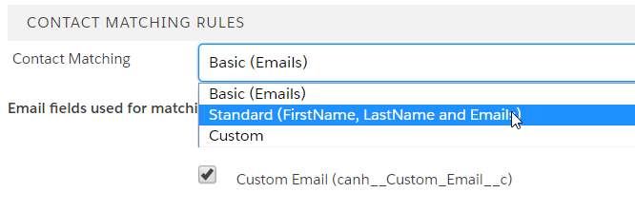
The CanadaHelps package includes three different options when it comes to contact matching/ deduplication rules.
Basic - This will match on email address only. You can select either a single or multiple, and either standard or custom email address fields on the contact record to match on.
Standard - This is the recommended matching. Standard matching will use the Contact first name, last name and Email address fields to match on. You can select either a single or multiple, and either standard or custom email address fields on the contact record to match on.
Custom - Custom setting allows for you to select up to three (3) contact fields to match on. Custom settings uses "AND" logic for the fields selected. For example: LastName AND Email AND PostalCode.

Custom contact matching
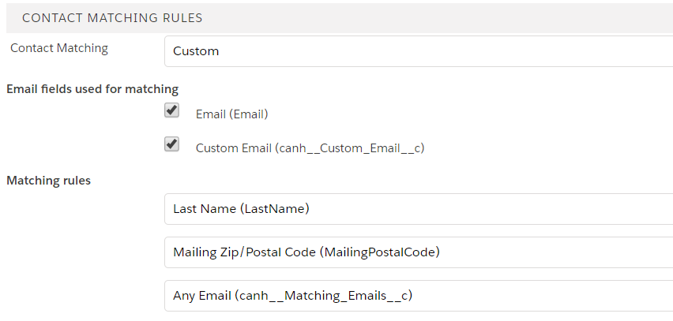
Custom - Custom setting allows for you to select up to three (3) contact fields to match on. Custom settings uses "AND" logic for the fields selected. For example: LastName AND Email AND PostalCode.

Field mapping
The field mapping tab of the CanadaHelps settings object comes preset to map each column of the CanadaHelps CSV into Salesforce standard Account, Contact and Opportunity objects and the custom fields that are included in the CanadaHelps package. If your organization uses NPSP (Nonprofit Success Pack), the package will detect this on install and use NPSP-specific mappings.
If you are installing the upgrade into a sandbox and it’s not a full sandbox, you will have to manually create the mappings since your existing mappings will not have migrated to the sandbox.
If, however, you have custom fields in your Salesforce instance that you would like to map to, you can change the default field map via the mapping tab.
**Note: if you are using NPSP version 3.0, it is recommended that you change the default mapping for {Contact.Id} on the Opportunity object from Individual Donor to the Primary Contact field to align with NPSP 3 functionality. **
**Note: it is possible that you have custom fields in your Salesforce instance that are required on the Contact, Account or Opportunity object. If so, you will need to ensure that these fields have a field mapping in the connector to prevent errors. **

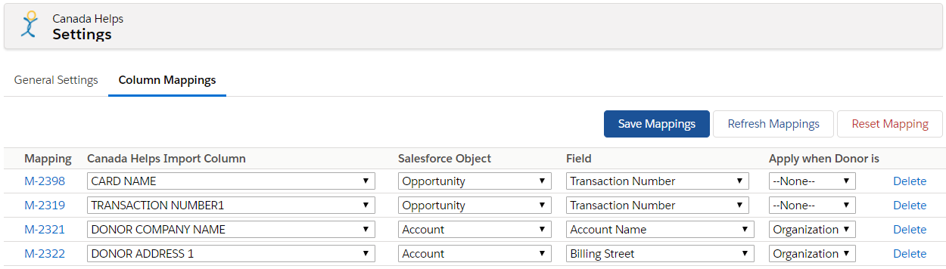
Save Mappings will save any mapping changes or new mappings that you have added. Refresh Mappings will undo any changes or new mappings and allow you to start over. Reset Mapping will revert all mappings to the original mappings from the package installation.

Changing an active mapping
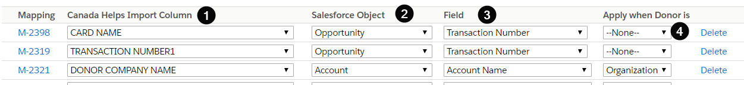
1) Find the CanadaHelps CSV Column you want to change.
2) If applicable change the Salesforce Object.
3) If applicable change the Salesforce field.
4) Select when the mapping should be applied- Individual Donor, Organizational Donor or None for either donor type.
Additionally, you can delete an active mapping by clicking the delete button at the end of a Mapping row.

Creating a new mapping
At the bottom of the mapping tab in the CanadaHelps setting tab you can also create new mappings.
1) Select the CanadaHelps CSV column.
2) Select the Salesforce object.
3) Select the Salesforce field
4) Select whether the mapping applies to individual or organization gifts
5) Click add.
Now the new mapping will appear as the last entry on the Mapped fields above. Be sure to click the Save Mappings button in order to save the new mapping before you navigate away from the page.

Custom CanadaHelps export columns
If your organization has customized the column names on the CanadaHelps export file or added additionally columns to the export file, you can update the Connector package to map those columns.
First, navigate to the setup menu, and then locate the Custom Settings menu item under the Custom Code section. You can filter setup menu items using the text box at the top of the menu.
The two custom settings that relevant to the mapping page are CSV Header and Static CSV Headers. You will be adding/modifying both depending on what customizations you have made to CanadaHelps export file.

Adding a new column
If you have added a new custom column to the CanadaHelps export, you will need to add the column name as a new value in the CSV Headers custom setting. In the setup menu, click the Manage link next to the CSV Headers custom setting. You should see a list of all the current columns in the export file.
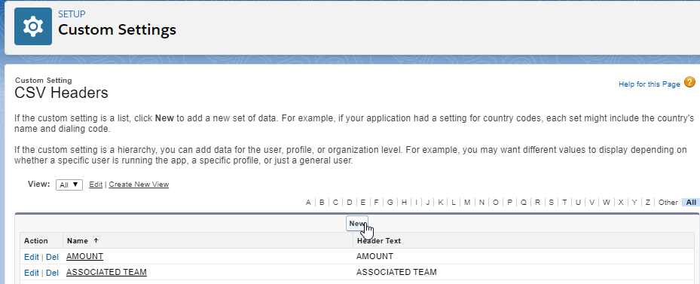
Click the New button to add a new CSV Headers value to this list.
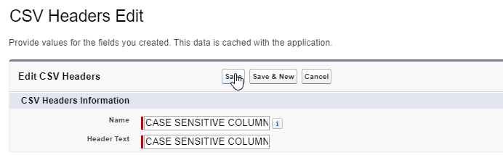
The Header Text field must exactly match the name of the column in the export file. This field is case sensitive. Additionally, put the name of the column in the Name field. This field allows less characters than Header Text, so if your new column has a long name, you may need to truncate the value in the Name field. Click Save.
You can now navigate back to the Mapping tab in Canada Helps Settings and a new mapping with your custom column.

Modifying an existing column
If your organization has a custom name for one of the standard CanadaHelps column (eg. Pay Method instead of Payment Method), you will need to adjust the custom settings so that the Connector package uses your customized column name.
In the setup menu, click the Manage link next to the CSV Headers custom setting. You should see a list of all the current columns in the export file.
In the list, find the column that your organization has modified (eg. Payment Method), and click the Edit link next to that value in the list.
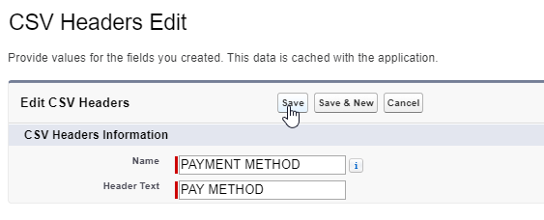
Modify the Header Text field to match your customized version of the column. The Header Text field must match the column in your CanadaHelps file exactly and is case sensitive.
If you have modified one of the following four columns: DONOR LAST NAME, DONOR EMAIL ADDRESS, TRANSACTION NUMBER, DISBURSEMENT STATUS, you will also need to modify the column header in the Static CSV Headers custom setting. Navigate back to the list of all custom settings and click the Manage link next to the Static CSV Headers custom setting.
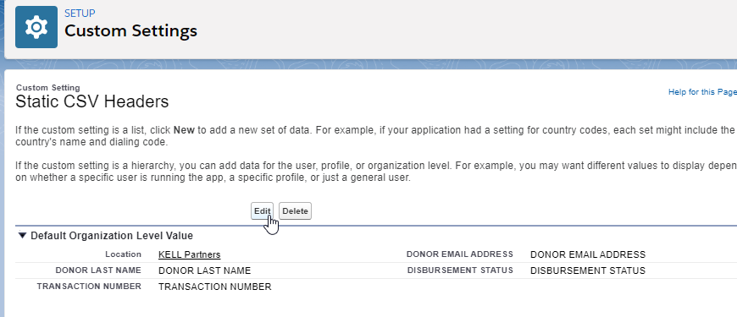
You will see all four of the columns listed. Click Edit and modify the column name to exactly match your customized version of the column name (these values are case sensitive), then click save.
Finally, navigate to the Canada Helps Settings tab and select Column Mappings. You will need to update the mapping of your customized column, which will appear as – UNDEFINED – in the data map.

